Chapter 13 – Section 1 Introduction
In September 1878, a young inventor from Menlo Park, New Jersey, went to see a set of experimental arc lights. The lights were too hot and bright for practical use, but they fascinated him. The more he studied the lights and the generator that powered them, the more excited he became.
The inventor, Thomas Alva Edison, knew he could invent a better lighting system, one that could be used anywhere. At the age of 31, he was already known as the "Wizard of Menlo Park." Among his many inventions were the phonograph and a highly efficient automated telegraph system. Now Edison vowed to invent a practical incandescent lamp—what we would call a light bulb.
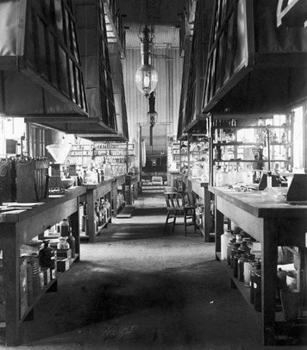The Granger Collection, New York
Edison’s laboratory in New Jersey, around 1900
Edison and his team of scientists and mechanics set to work. Other inventors had tried for decades to produce a practical light bulb. The main problem was finding a filament—a thin fiber or wire—that would heat to a bright glow when electric current passed through it, but would not melt. Edison tried thousands of materials, from platinum to twine to human hair. Finally, around 1879, he tried bamboo fibers that he had pulled from a Japanese fan. After carbonization—the process of converting a fiber to pure carbon—the bamboo filament burned and burned without melting. Edison finally had his light bulb.
That major success did not end Edison's quest. He was already hard at work on other components of a complete electric lighting system. He and his team were designing generators, meters, and cables. They were making plans for distributing electricity. They were installing lighting displays to promote the benefits of the electric lamp. Edison did not simply invent the light bulb. He envisioned the future of electricity, and he acted to make his vision a reality.
Inventions like Edison's light bulb helped spur a new age of innovation and industry after the Civil War. This period also saw the rise of big businesses that created great wealth. This chapter explores how industrialization affected the nation as a whole. The next chapter examines its effects on workers.

Chapter 13 – Section 2 New Inventions and Technology

Edison was one of thousands of ingenious inventors, mechanics, and scientists working to create new products and machines in the late 1800s. Thanks in part to their work, American life changed dramatically. The United States evolved from a largely agricultural nation into a complex industrial society.
This shift brought modern conveniences to many consumers. In 1865, Americans still lived in the "horse and buggy" era. They lit their homes with candles or oil lamps. They kept fresh foods in an icebox, a cabinet cooled by a large block of ice. And they waited a month or more for letters to cross the country. By 1900, many Americans illuminated their homes with electric lights. They kept foods cold in an electric refrigerator. They could send news across the continent in an instant by telegraph or telephone. A few could even afford to replace their horse and buggy with a new automobile.
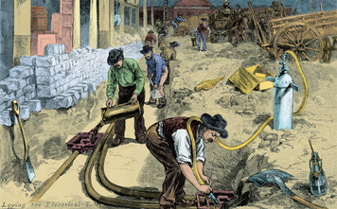
Thomas Edison’s light bulb was one of many innovations that dramatically changed the daily lives of Americans. By the early 1900s, many people had electricity and refrigeration in their homes. They could travel and communicate more rapidly. This print from 1882 shows workers laying tubes for electric wires on the streets of New York City.
Americans Invest in New Technology These innovations captured the imagination of investors who were willing to finance, or fund, the development of new products. Without this financial backing, many inventions would never have reached the market. Some would never have been built at all.
This willingness to risk money on new businesses lies at the heart of capitalism [capitalism: an economic system in which factories, equipment, and other means of production are privately owned rather than controlled by government] . Capitalism is an economic system in which factories, equipment, and other means of production are privately owned rather than being controlled by government. Capitalists in the late 1800s provided the funds to build railroads and factories and furnish them with machinery and supplies. They put money into new technology and scientific research. In return for risking their money, they hoped to reap rewards if the new business proved profitable.
Edison, for example, received generous financial support from a group of capitalists led by the wealthy banker J. P. Morgan. Together they formed the Edison Electric Light Company. In 1880 alone, this group provided the inventor with $150,000. In return, Edison gave the company the rights to his lighting inventions for a five-year period. The investors helped Edison pursue his vision, and they profited handsomely as a result.
Financial backers often protected their investments by making sure inventors acquired patents. A patent gives an inventor the sole legal right to make or sell an invention for a specified period of time. The federal government began issuing patents in 1790. By 1860, only 36,000 had been granted. Between 1860 and 1900, the number skyrocketed to more than 600,000. Edison holds the record for patents issued to one person, with 1,093 in all.
Revolutionary Changes in Communication and Transportation The use of electricity had brought dramatic progress in communications even before the Civil War. Artist and inventor Samuel F. B. Morse created the first practical telegraph by 1837. To send messages by electrical signal, he used a dot-and-dash system later known as Morse code. In 1843, Morse set up an experimental telegraph line linking Washington, D.C., with Baltimore, Maryland. He opened this line to commercial use the following year.
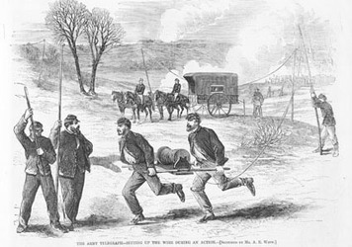Library of Congress
In this illustration from 1863, soldiers set up an army telegraph line. The first telegraph lines went up in 1843. By 1866, companies had installed over 75,000 miles of wire. At first, railroads and newspapers took the greatest advantage of this high-speed means of communication. Soon many others benefited. By 1911, the nation had 1.5 million miles of telegraph wire. Someone could send a telegram from almost anywhere in the United States to almost anywhere else.
Telegraph lines soon crisscrossed the countryside, mainly following railroad tracks. The railroads relied on the telegraph to keep track of their trains. Newspapers also used the telegraph to gather information and send stories to local newspapers. Several companies established telegraph networks. By the 1870s, however, the Western Union Telegraph Company dominated the industry. By 1900, nearly a million miles of telegraph wires were carrying more than 60 million messages a year.
The next revolution in communications came with the telephone. For nearly 12 years, the inventor Alexander Graham Bell had pursued the idea of sending speech over wires. He finally succeeded on March 10, 1876. According to popular legend, the first telephone message was the result of an emergency—with Bell calling out to his lab assistant, Watson, after accidentally spilling acid. However, in a letter to his father, Bell made no mention of any accident:
I was in one room at the Transmitting Instrument and Mr. Watson at the Receiving Instrument in another room—out of ear shot. I called out into the Transmitting Instrument, "Mr. Watson—come here—I want to see you"—and he came! He said he had heard each word perfectly . . . I feel that I have at last struck the solution of a great problem—and the day is coming when telegraph wires will be laid on to houses just like water or gas—and friends converse with each other without leaving home.
Bell's invention attracted plenty of financial support. In 1877, he founded the Bell Telephone Company. That same year, the first commercial telephone line was strung in Boston, where Bell lived. By 1893, more than 250,000 phones were in use. That year, Bell's patent ran out, allowing others to profit from his invention. Independent telephone companies formed across the country, helping create a surge in home use of the new technology. By 1920, the number of telephones had grown to at least 13 million.
Two other inventions changed how Americans moved. The first, the automobile, came to the United States from Europe. The second, the airplane, was home grown. In 1903, the brothers Orville and Wilbur Wright made the first successful powered-airplane flights in history, near Kitty Hawk, North Carolina. After that first success, inventors worked continually to improve airplane design.
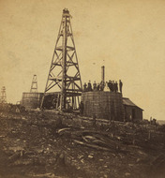Library of Congress
Oilfields like this one in Pennsylvania marked the birth of a huge new industry. Drilling companies took petroleum out of the ground. Refiners turned it into kerosene for lamps and into oil for lubricating machinery. Later they refined it into gasoline for automobiles.
"Rock Oil" Provides a New Source of Fuel The development of new fuels gave rise to another new industry. Before the Civil War, lamps mainly burned whale oil, which was very expensive. In the mid-1800s, a Canadian scientist discovered how to refine crude oil that seeped out of the ground into a lamp oil called kerosene. But the supply of surface oil was limited. Then a former railroad conductor named Edwin Drake made an important discovery.
In 1858, Drake went to Titusville, Pennsylvania, on business. He had bought stock in the Pennsylvania Rock Oil Company, which gathered surface oil for use in medicine. While in Titusville, Drake studied the techniques of drilling salt wells. Drake decided to lease land from the company for oil drilling. In August 1859, after several weeks of drilling, he struck oil.
Countless more wells were drilled in Pennsylvania and 13 other states. Oil drilling and refining became a huge industry, supplying fuel for lamps, lubricating oils for machinery, and later, gasoline for automobiles.
The Bessemer Process Revolutionizes Steelmaking A new technology for turning iron into steel gave rise to another major industry. Iron is a useful metal, but it is brittle and fairly soft. Steel is a purified form of iron mixed with carbon. Engineers prefer steel for most purposes because it is harder, stronger, and lighter than iron. Before the 1850s, however, the process for making steel out of iron was time-consuming and expensive.
In 1855, a British inventor named Henry Bessemer patented a new method of making steel. The Bessemer process [Bessemer process: a method of steelmaking invented in 1855 that enabled steel to be made more cheaply and quickly] involved blowing air through molten iron. The blast of air removed impurities. Using this process, steel could be produced far more cheaply and quickly than in the past. After seeing the process at work in England, Andrew Carnegie decided to invest heavily in steel production in the United States. In 1873, he began to form the Carnegie Steel Company, which later built the largest and most modern steel mill of its time near Pittsburgh, Pennsylvania.
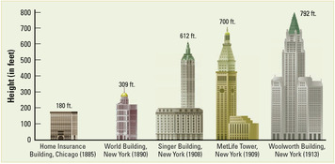

The skyscraper relied on two technologies developed in the 1850s. The Bessemer process produced cheap steel, which was lighter and stronger than iron or brick. Engineers could now build tall structures that didn’t collapse under their own weight. Invention of the passenger elevator provided easy access to the higher floors.
As the steel industry grew, steel became the metal of choice for heavy construction. Railroads switched to steel rails. Builders began using steel to construct longer bridges and taller buildings. In 1883, the longest suspension bridge in the world opened. This towering structure, the Brooklyn Bridge, stretched for 6,700 feet across the East River in New York City. Two years later, builders erected the world's first skyscraper, a 10-story building in downtown Chicago. Neither of these structures could have been built without the use of steel.
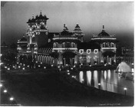Library of Congress
The Electricity Building brightened the Pan-American Exposition of 1901 in Buffalo, New York. This site illuminated recent advances in the field of electricity. Displays included a variety of innovations in typesetting technology and electric machinery.
Electricity Lights Up America A single invention can have far-reaching effects. Edison's light bulb, for example, gave birth to the electric power industry. In 1882, Edison built a central generating station in New York City. Its wiring electrified a section of lower Manhattan. Before long, the demand for electricity became too great for the Edison Electric Light Company to meet on its own. Throughout the country, other companies built their own central generating stations to meet customers' needs. By 1891, there were more than 1,300 stations, providing enough electricity to power about 3 million light bulbs.
Access to electricity had a huge impact on American industry. Artificial light allowed businesses to stay open longer. Factories could run through the night. Electricity changed home life too. Americans could not only work and read at night but also plug in electric refrigerators and other appliances. Electricity was costly at first, though, and power companies built stations mainly in the cities. Many Americans, especially in rural areas, had to wait decades more for electric transmission lines to reach them.

Chapter 13 – Section 3 An Explosion of Industrial Growth

The growth of technology and the creation of communication and electric power networks helped fuel the expansion of American industry in the late 1800s. Companies that had once served mainly local markets expanded to sell their goods nationwide. To meet the needs of this growing national market, companies developed new ways of operating.
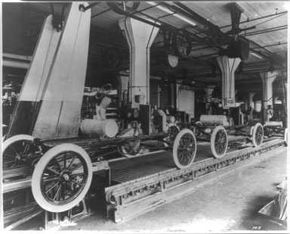
Library of Congress
Men, women, and children operated the new machines that powered the industrial age. Workers often stood at their machines for 10 to 12 hours a day, with few breaks. For reasons of efficiency, they did the same task over and over again. This system boosted productivity, but it made the work dull and exhausting.
New Ways to Manage Work Farsighted business owners realized they could profit from serving customers nationwide. But to do this, they had to create systems of mass production that would enable them to supply a much larger market. The basic elements of this system already existed. By the early 1800s, factories were using interchangeable parts to produce goods in large quantities.
After the Civil War, factory owners improved these methods of mass production. They built specialized machinery that could produce identical parts for quick assembly into finished products. They no longer needed skilled artisans to craft individual parts. Instead, they could use unskilled workers to run the machines and hire supervisors to manage the day-to-day operations.
Engineers reorganized factory work to increase productivity, dividing up the production process so that each worker did a single task. One engineer, Frederick W. Taylor, used scientific techniques to analyze these tasks. He watched workers and timed them with a stopwatch. Through these time-and-motion studies, he determined the most efficient way to perform each task. He trained workers to work faster by reducing wasted motion. Speed boosted productivity, which increased profits.
Taylor later published his findings in a book called The Principles of Scientific Management. The book had a profound effect on industry in the early 1900s. One person who took it seriously was Henry Ford, who pioneered the moving assembly line to mass-produce automobiles. In a Ford plant, there was no wasted motion. Workers stood in one place all day, while a conveyor belt brought the work to them. Each worker did one or two small tasks, and then the belt moved the car to the next worker's station. One worker might put bolts in the frame while the next worker tightened them down. The process continued, part by part, until the car rolled off the assembly line, ready to be driven away.
Increased productivity resulted in cheaper goods. But it also meant that a factory could operate with fewer workers. Those who remained had to perform the same dull task all day long, but at a faster pace. Many assembly-line workers felt as though they had become machines. As you will read in Lesson 14, workers often protested for better working conditions.

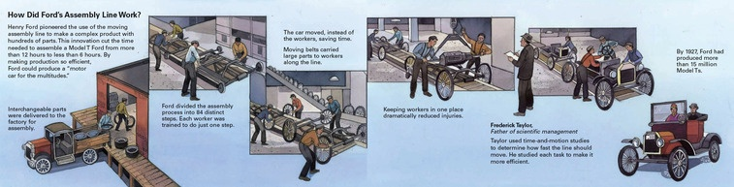
New Ways to Finance and Organize Businesses Before the Civil War, individual owners ran most businesses. As businesses grew larger, however, their need for the three basic factors of production [factors of production: land, labor, and capital] —land, labor, and capital—grew as well. Land, which includes resources such as soil, forests, and minerals, was still abundant. Labor was plentiful as well thanks to a steady stream of immigrants into the country during this period. Capital [capital: any financial asset-including money, machines, and buildings-used in production] , however, was a problem. Capital is any asset that can be used to produce an income. Money, buildings, tools, and machinery are all forms of capital.
Small business owners did not have all the capital they needed to expand. For this reason, many of them formed corporations [corporation: a company recognized by law to exist independently from its owners, with the ability to own property, borrow money, sue, or be sued] .
A corporation is a company that is recognized by law as existing independently from its owners. A corporation can own property, borrow money, sue, or be sued. People invest in corporations by buying stock, or a share in the ownership of the business. By buying stock, investors became owners of the company. The money they paid for their stock helped to finance the corporation. Wealthy capitalists controlled corporations by buying huge amounts of stock.
As owners of a corporation, stockholders could profit from its success. Unlike the owners of small businesses, however, investors were not liable for a corporation's debts. The most they could lose was the amount they invested. Also, these owners did not run the daily operations. The corporation hired managers, accountants, engineers, and others to keep production going.
Competition among corporations provided consumers with a wide choice of new products, but it caused headaches for business owners. In the battle to sell products, companies slashed prices. Profits fell, debts rose, and many companies went bankrupt. Cutthroat competition threatened to drag down even the best-run companies. As a result, some powerful capitalists decided that to stay in business, they would have to limit competition.
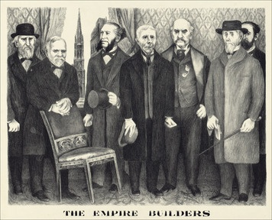Library of Congress
Industrialists profited from new ways of financing and organizing businesses. Andrew Carnegie (second from left) used efficient business practices and new technology in his steel plants. Carnegie and other “captains of industry” also set up trusts and built mono- polies. These forms of big business brought them great personal wealth.
Business owners began devising ways to reduce competition. One method was to buy or bankrupt competitors. John D. Rockefeller had great success with this approach in the oil industry. During the 1860s, he earned a fortune refining oil in Cleveland, Ohio. In 1870, he formed a corporation called Standard Oil. Standard Oil expanded by buying out or merging with other companies. Rockefeller's company also undercut its competitors by making deals with railroads, which agreed to ship its oil at discount prices. The savings on shipping allowed Standard Oil to cut its oil prices. These price cuts forced smaller oil companies to reduce prices too, causing many of them to either be sold to Standard Oil or go bankrupt. Rockefeller told one independent oil refiner, "You can't compete with the Standard . . . If you refuse to sell, it will end in your being crushed."
By 1882, Standard Oil had become a monopoly [monopoly: a company that completely dominates a particular industry] , a company that completely dominates a particular industry. It controlled 90 percent of the nation's oil production. With its competitors out of the way, Standard Oil could raise its prices and reap great profits.
Another approach to reducing competition was to form business trusts [trust: a set of companies managed by a small group known as trustees, who can prevent companies in the trust from competing with each other] . A trust is a set of companies that are managed by a small group known as trustees. The trustees have the power to prevent companies in the trust from competing with each other.

Chapter 13 – Section 4 Big Business and Government
Trusts and monopolies concentrated capital—and power—in the hands of a few people. With less competition, companies grew larger and more profitable. Americans began to refer to these industrial giants as "big business." Unlike owners of small, traditional businesses, those who ran huge corporations seldom knew their workers. Big business was impersonal, extremely profit-driven, and responsive mainly to investors.
Businesses Grow Larger and More Powerful Corporations generally expanded in one of two ways. The first strategy was horizontal integration [horizontal integration: a corporate expansion strategy that involves joining together as many firms from the same industry as possible] . This approach called for joining together as many firms from the same industry as possible. An example was Standard Oil's practice of buying up refineries to gain control of the oil-refining industry.
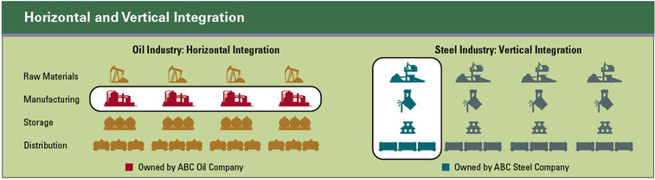
Some industrialists, like John Rockefeller, expanded their business through horizontal integration. They worked to buy up every company they could in the same business. In Rockefeller’s case, horizontal integration led to monopoly. Others, like Andrew Carnegie, expanded through vertical integration. They worked to bring every process of their business--from generating raw materials to marketing the finished product to consumers--under their control.
A second strategy was known as vertical integration [vertical integration: a corporate expansion strategy that involves controlling each step in the production and distribution of a product, from acquiring raw materials to manufacturing, packaging, and shipping] . This approach involved taking control of each step in the production and distribution of a product, from acquiring raw materials to manufacturing, packaging, and shipping. Carnegie expanded his steel company through vertical integration. He bought the iron mines and coalfields that sent raw materials to his company's mills. He bought the ships and railroads that transported supplies and finished products. Vertical integration gave Carnegie complete control of the production process and the power to dominate the steel industry.
The Government Leaves Business Alone By the late 1800s, many Americans realized that big business was limiting competition. Lack of competition allowed prices to rise, which helped producers but hurt consumers. However, lawmakers were unwilling to stop such business practices. Most politicians had long favored a policy of laissez-faire [laissez-faire: the idea that the free market, through supply and demand, will regulate itself if government does not interfere] . This doctrine held that the market, through supply and demand, would regulate itself if government did not interfere. The French phrase laissez-faire translates as "allow to do." To political leaders, this meant "leave business alone."
Another influential idea at the time, social Darwinism [social Darwinism: an idea, based on Charles Darwin's theory of evolution, that the best-run businesses led by the most capable people will survive and prosper] , also discouraged government regulation of business practices. Based on Charles Darwin's theory of evolution, social Darwinism held that the best-run businesses led by the most capable people would survive and prosper. This doctrine's most avid supporter, Herbert Spencer, coined the phrase "survival of the fittest." Social Darwinists argued that government should leave businesses alone to succeed or fail on their own.
In reality, the federal government did not leave businesses alone, but actually helped many of them. It gave the railroads hundreds of millions of dollars worth of land. It sold natural resources such as forests and minerals at very low prices to companies that were prepared to exploit them. It also imposed protective tariffs on foreign goods to make them more expensive than American-made goods. Tariffs forced consumers to pay higher prices than they would have in a free market.
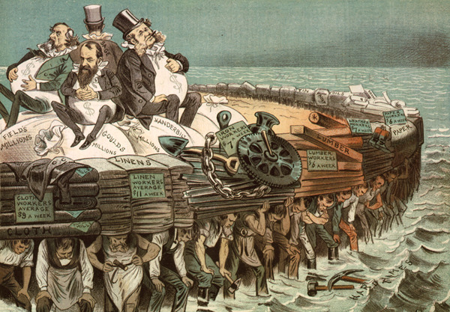
Library of Congress
This cartoon, titled “The Protectors of Our Industries,” shows four wealthy industrialists—Marshall Field, Cornelius Vanderbilt, Jay Gould, and Russell Sage—sitting on their moneybags. These “protectors” amassed huge fortunes while paying their workers, seen below, as little as possible. Gould was widely viewed as the most corrupt of the robber barons. He considered himself the most hated man in 19th-century America.
During the late 1800s, some businesses bribed legislators to pass laws favoring their companies. Much of the free land handed out to the railroads, for example, came in return for cash payments to politicians. In 1904, journalist Lincoln Steffens wrote, "Our political leaders are hired, by bribery . . . to conduct the government of city, state, and nation, not for the common good, but for the special interests of private business."
Tariffs and other government aid did help industry prosper. In the late 1800s, the American economy grew rapidly. From 1877 to 1900, the value of American exports doubled. By 1900, the United States had the strongest industrial economy in the world.
Government Takes Some Action to Limit Business As trusts and monopolies multiplied, many Americans grew alarmed that they were denying opportunities to smaller businesses. A few states passed laws or filed lawsuits to try to restore competition. Big business, however, just kept getting bigger.
Increasing public concern finally provoked a response from the federal government. In 1890, Congress passed the Sherman Antitrust Act [Sherman Antitrust Act: an 1890 federal law that outlawed trusts, monopolies, and other forms of business that restricted trade] , which outlawed trusts, monopolies, and other forms of business that restricted trade. However, the government made only feeble attempts to enforce the new law. One problem was the wording of the law. Written by lawyers who favored laissez-faire, the Sherman Antitrust Act was full of vague language. Congress left it to the courts to clarify the law, but the courts were not impartial, or unbiased. They often interpreted the law in favor of big business. For example, in 1895 the Supreme Court blocked government efforts to break up a sugar trust that controlled most of the nation's sugar manufacturing. In United States v. E.C. Knight Co., the Court ruled that the Sherman Act applied only to trade, not to manufacturing.

Chapter 13 – Section 5 The Gilded Age
In 1873, the writer Mark Twain coauthored a book about rich industrialists and corrupt politicians called The Gilded Age. Something that is gilded looks like gold, but only on the outside. The title described American society in this period well. Industrialists who had made great fortunes led glittering lives. But beneath that glitter, this period was marked by political corruption and social unrest.
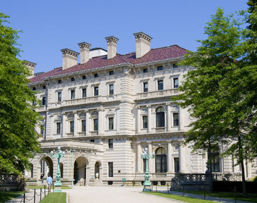

Mikhail Kusayev | Dreamstime.com
Wealthy industrialists lived in grand style during the Gilded Age. Many “captains of industry” built lavish homes, such as the Vanderbilt Breakers mansion in Newport, Rhode Island. Meanwhile, many of their workers lived in poverty.
From Industrialists to Philanthropists During the Gilded Age, the growth of three industries fueled a rapid expansion of the American economy. From 1870 to 1900, steel production rose from 77,000 tons to more than 11 million tons. Oil production swelled from around 5 million barrels annually to more than 63 million barrels. Railroad track expanded from 53,000 to around 200,000 miles. From these industries, three towering figures emerged: Carnegie, Rockefeller, and Cornelius Vanderbilt. All three started as entrepreneurs [entrepreneur: a bold, ambitious person who establishes a new business] —bold risk-takers who established new businesses. Along the way, they amassed huge fortunes.
In 1890, Carnegie earned $25 million. That year, the average industrial worker made about $440. Carnegie lived in a 4-story, 64-room mansion on Millionaire's Row in New York City. Workers near his Pittsburgh mill lived in cramped, poorly ventilated rooms with primitive sanitation. This huge gap in living standards did not bother most industrialists. Some would have explained it as social Darwinism in action. Others might have said that by working hard and following Carnegie's example, anyone could be rich.
Carnegie's rags-to-riches story supported such views. After arriving from Scotland in 1848 at the age of 12, he worked in a Pennsylvania cotton mill earning $1.20 a week. His thrift and shrewd investments gave him a $50,000 annual income by the time he was 30. Through a combination of daring business tactics and technological innovation, Carnegie prospered and gained control of several steel plants. In 1889, the year before his income hit $25 million, he published an article titled "Wealth." In it, he declared that rich people had a duty to use their surplus wealth for "the improvement of mankind." He added, "A man who dies rich dies disgraced."
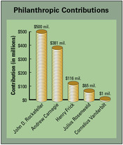

Some successful industrialists used their wealth to promote the common good. Rockefeller and Carnegie gave away huge sums. Henry Clay Frick, Carnegie Steel’s chairman of the board, followed his boss’s example. Julius Rosenwald, head of Sears, Roebuck and Company, was also a generous philanthropist. Vanderbilt willed most of his $100 million fortune to his son, but did give away $1 million to found Vanderbilt University.
Carnegie set a splendid example by using his fortune to benefit society. In 1911, he established the Carnegie Corporation of New York. This charitable foundation offered grants of money to promote the advancement of knowledge. It focused on education, especially libraries. Carnegie helped build more than 2,500 free public libraries throughout the world. He also used his money to support cultural institutions and to promote international peace.
Like Carnegie, Rockefeller had the foresight to get in on the ground floor of an industry with a bright future. He started with one oil refinery, which he built into a huge corporation, Standard Oil. Rockefeller's monopolistic approach to business brought him fabulous wealth—and a terrible reputation. In an era of tough competition, he stood out for his ruthless tactics. However, like Carnegie, he became a philanthropist [philanthropist: a person who gives money to support worthy causes] , a person who gives money to support worthy causes. He used his fortune to help establish the University of Chicago in 1892. He also started several charitable organizations, including the Rockefeller Foundation. Through these organizations, he supported medical research, education, and the arts.
Cornelius Vanderbilt followed a similar path to wealth. In 1810, at the age of 16, he started a ferry business in New York Harbor. Later he built up a fleet of steamships. By upgrading his ships and cutting shipping rates, he prospered. Ambitious and clever, Vanderbilt mastered the world of trade and transportation. He set up a profitable route from New York to San Francisco in time to carry many forty-niners to the goldfields. In 1862, he sold his steamer business and invested in railroad stock. He soon owned several rail lines, opening the first direct service from New York City to Chicago. Unlike Carnegie and Rockefeller, however, Vanderbilt never believed he had a duty to use his wealth to benefit society. Nevertheless, in 1873, he donated $1 million to found Vanderbilt University in Nashville, Tennessee.
Robber Barons or Captains of Industry? History is not quite sure how to judge the business giants of the Gilded Age. Critics call them robber barons for the way they gained their wealth and the lordly style in which they lived. Supporters call them captains of industry who, despite some shady dealings, helped usher in our modern economy.
From the critics' point of view, the industrialists prospered for mostly negative reasons. They ruthlessly drove rivals out of business and raised prices by limiting competition. They robbed the nation of its natural resources and bribed officials to ensure their success. They kept wages low and imposed dreadful working conditions, while trying to squeeze every ounce of work out of their employees.
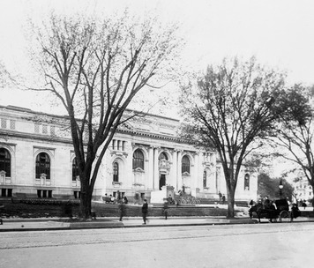
Library of Congress
Much of the philanthropy of a century ago still provides benefits today. Charitable foundations established in the Gilded Age continue to support worthy causes. Libraries like this one, built through a Carnegie grant, remain vibrant institutions in many communities.
Supporters argue, however, that industrialists prospered for mostly positive reasons. They worked hard and took advantage of new technology. Industrialists found new ways to finance and organize businesses for greater efficiency and productivity. And their success created jobs for millions of Americans. Shopkeepers, doctors, lawyers, and others in the growing middle class profited from the up-surge in business. Their living standards climbed along with the rising economy. But it would take years of struggle before workers shared in these benefits, as you will read in the next chapter. Perhaps the greatest inequality in American history occurred during the Gilded Age.
This debate about the overall impact of the industrialists may never be resolved. But one thing is clear. The industrial expansion of the late 1800s helped give rise to a vibrant economy and consumer society. Americans had access to an unprecedented abundance of goods and services—and they kept demanding more. By the early 1900s, economic growth had helped make the United States one of the most powerful nations in the world.

Chapter 13 – Summary
Innovations in technology and business boosted American industry in the late 1800s. Large steel, oil, and railroad corporations dominated the economy, with little governmental control. Industrial expansion produced greater access to goods and services, and it improved standards of living for many Americans, but not all.
Innovations and inventions Innovations, such as the electric light bulb and kerosene, spurred the growth of new industries. The telegraph and telephone brought modern communications to homes and businesses. The Bessemer process lowered the cost of steel and encouraged new forms of construction.
New business techniques Business leaders formed corporations to attract capital from investors, who became owners by buying stock. They improved production methods in order to mass-produce more goods in less time. By promoting horizontal or vertical integration, some leaders gained control of major industries. They also sought to reduce competition by forming monopolies and trusts.
Laissez-faire The federal government generally adopted a laissez-faire policy toward business. This hands-off approach reflected a belief in social Darwinism. The Sherman Antitrust Act was only feebly enforced.
The Gilded Age While industrialists amassed great fortunes, society was tainted by political corruption and a huge gap between rich and poor. Carnegie, Rockefeller, and Vanderbilt used some of their wealth to promote the common good. Historians debate their overall impact, noting increased industrial productivity but also unfair business practices.

