Lesson 14 Section 1- Introduction
In 1898, a young woman named Rose Schneiderman was hired at a factory in New York City. Her job was to sew the linings into men's caps. But she would soon take on a much larger role in the story of American labor.
Like most factory workers at the time, Schneiderman worked long hours under difficult conditions. At night, she returned home to a crowded, run-down apartment. But Schneiderman was determined to improve these conditions. She began to organize the workers at the cap factory. Before long, she had become a leader of the New York City branch of the Women's Trade Union League, a national labor organization.
In 1909, Schneiderman helped organize a major labor action known as the "Uprising of 20,000." In this event, thousands of young women walked off their jobs making clothing at garment factories in New York. The women were demanding higher wages and better working conditions. Some companies made settlements with the workers. However, demands for unlocked factory doors and working fire escapes were never met. Although their walkout failed to achieve all of their goals, it did set the stage for more labor actions to come.
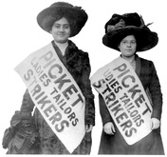
Two years later, a tragedy at a garment factory helped focus even more attention on the plight of workers. In 1911, the Triangle Shirtwaist Factory caught fire. Because the doors to the factory were locked, many of the women couldn't escape. One hundred forty-six workers died in the fire. Afterward, on April 2, Schneiderman gave an impassioned speech. In it, she said,
This is not the first time girls have been burned alive in the city. Every week I must learn of the untimely death of one of my sister workers . . . The life of men and women is so cheap and property is so sacred . . . It is up to the working people to save themselves. The only way they can save themselves is by a strong working-class movement.
Over the years, Schneiderman continued her efforts on behalf of American workers. She became one of the key figures in the American labor movement.
Lesson 14 Section 2:
Americans have long cherished the ideal of equality. Unlike European countries, the United States has never had monarchs or noble families who held economic and political power just because they were part of an upper class. In the Gilded Age, however, a class system started to emerge in the United States. That is, society began to divide into unequal groups based on wealth and power.
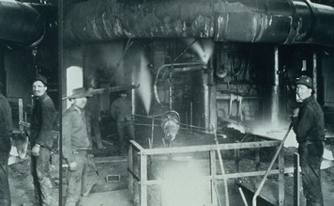
In 1879, the economist Henry George described this change as an "immense wedge" being forced through society. "Those who are above the point of separation are elevated, but those who are below are crushed down." The people being crushed belonged to the working class.
Many Workers Labored Under Terrible Conditions The working class included men, women, and children. They provided the skill and the muscle that helped push American productivity to new heights and made employers rich. Yet those same employers often treated their workers—their human resources—as if they were merely parts of the machinery.
Industrial workers had an exhausting schedule. They typically worked 6 days a week, for 10 or more hours a day. For their efforts, workers earned about $1 a day. The work itself was repetitive and boring. Unlike farming or craft work, in which a worker did a variety of tasks, the factory system relied on a division of labor. This meant that production was divided into separate tasks, with one task assigned to each worker. Factory owners designed the system this way for the sake of efficiency.
Workers often performed their tasks in hazardous environments. A priest described a steel plant as "the slaughterhouse; they kill them [workers] there every day." Whirling shafts, slippery floors, spinning blades, and molten steel all had the potential to injure or kill. Unlike today, worker safety was not a major concern. Workers were not given helmets or safety glasses, and those who were hurt or disabled received little or no financial compensation for their injuries. Factory owners believed that paying wages fulfilled their obligation to workers.
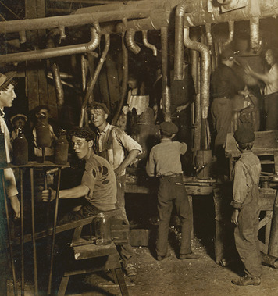
Industrial processing often created toxic gases and dust. Workers in textile mills, for example, inhaled cotton dust all day. Worse yet was the situation of coal miners. Mary Harris ("Mother") Jones, a labor activist, described the "wretched work" that miners did. Their lungs "breathe coal dust," she wrote, and "coal dust grinds itself into the skin, never to be removed." Textile workers and miners suffered from lung diseases. Workers in cramped, unventilated sweatshops faced the constant threat of contagious diseases such as tuberculosis. A sweatshop is a small factory where employees work long hours under poor conditions for low wages.
Laborers put up with such adversity, or hardship, because they could lose their jobs if they protested. With immigrants pouring into the country, employers had little trouble replacing a complaining worker.
Widespread Child Labor Children worked in industry for two main reasons. First, even with both parents employed, a typical family could barely survive. The child's wages, though meager, made a crucial difference. Secondly, children earned less than adults, so factory owners were happy to employ them. At the same time, children were expected to do the same amount of work as their parents.
Throughout the 1800s, critics voiced concerns about child labor. Some states enacted laws setting a minimum age for workers, often 14 or 15 years. However, these laws led to little change. Where child-labor laws existed, companies often ignored them, and states often failed to enforce them. As a result, 6-year-olds worked in Georgia's cotton mills, and boys as young as 8 worked in the coal mines of Pennsylvania. In 1907, poet Edwin Markham described a typical street scene in New York's garment district: "Nearly any hour on the East Side of New York City you can see them—pallid boy or spindling girl—their faces dulled, their backs bent under a heavy load of garments piled on head and shoulders."
Child workers experienced some of the most dangerous working conditions. Because they were small, they could squeeze inside running machinery to make repairs. Young miners driving mules through tunnels risked being crushed by loads of coal. In January 1876, a Pennsylvania newspaper noted, "During the past week nearly one boy a day has been killed" in the mines.
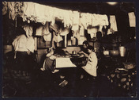
Unsanitary Living Conditions When their shifts finally ended, worn-out industrial workers headed home. For most, however, home offered little comfort. The great mass of workers, especially immigrants, lived in slums—heavily populated parts of a city marked by filth and squalor. Jane Addams, a social reformer, described a typical slum in Chicago:
The streets are inexpressibly dirty, the number of schools inadequate, sanitary legislation unenforced, the street lighting bad, the paving miserable and altogether lacking in the alleys and smaller streets, and the stables foul beyond description.
—Jane Addams, Twenty Years at Hull-House, 1910
In the slums, workers lived in tenements, run-down apartment buildings of four to six stories, usually housing four families on each floor. A New York commission noted that these families "cook, eat, and sleep in the same room, men, women, and children together." Disease flourished in such cramped and often airless quarters, and fire was an ever-present danger.
Section 3:
In the late 1800s, workers in American industry faced a set of painful facts. Their pay was low, and they worked in dangerous and unhealthy conditions. Their homes were often equally dismal, and their children had little opportunity to go to school. Whenever the economy slumped, life got even worse. Employers cut workers' pay or eliminated their jobs. Perhaps most distressing of all, individual workers had little power to change their circumstances. They could not bargain with employers. Nor could they seek help from the government, which did little to regulate working conditions.
Workers Unite for Better Conditions In the early years of the Industrial Revolution, some workers developed a strategy for improving their lives. They formed labor unions. A labor union is a group of workers organized to protect the interests of its members. Historically, most labor unions have focused on three primary goals: higher wages, shorter hours, and better working conditions.
The first worker organizations in the United States appeared in the late 1700s in New York City and Philadelphia. By the mid-1800s, local unions had formed in many other cities. Much of a union's power came from the threat of a strike, a labor action in which workers simply refuse to go to work. A strike could easily shut down a factory, railroad, or mine. Unions generally used the strike as a last resort, when owners would not sit down to discuss the issues.
A Difficult Start for National Labor Organizations After the Civil War, local unions began to realize that they might benefit from cooperating with each other to achieve their goals. As a result, a number of unions joined forces to form a national labor federation, or group of unions. This federation focused on efforts to establish an eight-hour workday. But poor leadership and lack of unity led to its collapse in 1872.
In the mid-1870s, an economic depression inflicted more damage on efforts to create national labor unions. In times of economic crisis, high unemployment intensified the competition for jobs.
Some business owners used this competition to undermine unions. They pressured workers to sign "yellow-dog contracts," written pledges not to join a union. Owners would not hire workers who did not sign a pledge. They also exchanged lists of union members and organizers, refusing jobs to any worker whose name was on these blacklists. Yellow-dog contracts and blacklists discouraged workers from joining unions.
Common Goals, Different Strategies During the depression of the 1870s, business owners' tactics succeeded in smashing many labor unions. After the economy regained its strength, however, the labor movement also revived. A series of new national labor organizations arose, bringing together various unions under one banner.
One of these new federations was the Knights of Labor. It attracted many members in the late 1870s with a policy of accepting both skilled and unskilled workers, including women and African Americans. However, the Knights declined after 1886, in part because of competition from another federation.
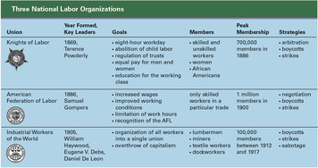
That rival group was the American Federation of Labor (AFL). Unlike the Knights, the AFL concentrated mainly on organizing skilled workers. It also had a more narrow focus on "bread-and-butter" worker objectives, such as higher wages and shorter workdays. Founded in 1886, the AFL became the only major national labor organization in the 1890s.
In the early 1900s, another labor organization arose, the Industrial Workers of the World (IWW). Its members were nicknamed Wobblies. IWW leaders introduced radical ideas into the union movement, adopting the socialist theories of the German political philosopher Karl Marx. Socialism is a political theory that advocates ownership of the means of production, such as factories and farms, by the people rather than by capitalists and landowners. Its goals are the elimination of private property and the fair treatment of workers. IWW members saw socialism as the path to a better life for workers.
In practice, each of these national labor organizations acted as a union. They engaged in collective bargaining—negotiations between employers and employee representatives concerning wages, working conditions, and other terms of employment. They also called strikes when collective bargaining failed.
Section 4:

As labor unions gained strength in the late 1800s, workers showed a greater willingness to strike. At the same time, business owners stubbornly opposed union demands. As a result, confrontations between unions and owners increased. These struggles intensified after a bitter railroad strike in 1877.
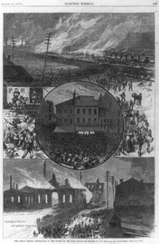
Violence Marks the Railroad Strike of 1877 The railroad strike began during the depression of the mid-1870s. The government, holding to its laissez-faire policy, did nothing to boost the economy or help suffering workers. As families starved and children died, rage boiled up in working-class communities.
Meanwhile, railroad companies responded to the depression by slashing wages. In 1877, rail workers in West Virginia went on strike. The strike soon spread across the country. Before long, strikers had shut down at least half of the nation's rail lines. It was the largest labor uprising in U.S. history.
To keep the tracks closed, strikers battled police and state militias. Meanwhile, riots broke out in various cities as strike supporters expressed their anger by burning and looting railroad property. Police and militia forces could not control the chaos. Finally, President Rutherford B. Hayes called in the army. He used federal troops to restore order and get the trains rolling again. It was the first time the U.S. Army had been used to break a strike, but it would not be the last.
Two weeks of turmoil had left about 100 people dead and millions of dollars worth of property destroyed. The violence and destruction alarmed many Americans. They feared a working-class revolution, perhaps led by socialists or other radical groups. Such a revolution did not take place, but the stage was set for even larger and more violent strikes.
More Strikes, More Violence The Railroad Strike of 1877 boosted union membership and gave members a greater sense of their own power. In the years that followed, national labor organizations tried to harness that power to change working conditions. Strikes became more numerous during this time. Three major events during this period underscored the growing struggle between owners and workers: the Haymarket Affair, the Homestead Strike, and the Pullman Strike.
The Haymarket Affair took place in Chicago in 1886. It started when strikers fought with "scabs," nonunion workers brought in to replace striking workers. Police trying to break up the fight shot into the crowd, killing at least one striker and wounding others. A group of anarchists—people who reject all forms of government—called for a protest meeting the next day in Haymarket Square.
More than a thousand people showed up for the meeting, including the city's mayor. Several speakers addressed the crowd. The mayor noted that the crowd remained calm. Near the end of the speeches, however, a force of about 180 Chicago police stormed in to break up the gathering. In the confusion that followed, someone threw a bomb that exploded among the police. Panicked, the police fired into the crowd, killing at least four protesters. Several officers died.

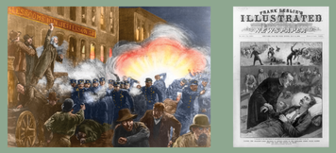
The bomber was never identified, but four radical anarchists were tried and executed for their part in the demonstration. The Haymarket Affair divided and confused the labor movement. Many workers backed the anarchists, but union leaders feared that supporting the radicals might further inflame public fears.
The Homestead Strike came several years later, in 1892. It involved iron- and steelworkers at the Carnegie Steel plant in Homestead, Pennsylvania. Andrew Carnegie was away in Europe at the time and had left his manager, Henry Frick, in charge. Frick hired 300 private guards from the Pinkerton Agency to protect the plant against the strikers. Industrialists had hired Pinkerton agents before. They often worked as spies, joining unions to discover their plans and identify union members. Though not police officers, the Pinkerton men carried guns.
When the Pinkerton agents arrived at the plant, the strikers were armed and ready. After a daylong gun battle in which nine strikers died, the Pinkerton agents gave up and the strikers took control of the town. Pennsylvania's governor then called out the state militia, and the strikers scattered. Frick brought in nonunion workers to run the plant, and the union was shut out for the next four decades.
In the Pullman Strike of 1894, the government again supported management against striking workers. The Pullman Palace Car Company, in the southern part of Chicago, made fancy railcars for long-distance travelers. Its employees all lived in the company town of Pullman. In company towns, workers rented company-owned housing and bought food and other goods at company stores, often at inflated prices. As a result, many workers owed large debts to the company. Often all of their wages went toward paying off bills at the company store.
In the spring of 1894, during another depression, Pullman cut wages, but not rents or other charges, by about 25 percent. Frustrated, the workers went on strike. The American Railway Union supported the Pullman Strike. Its members shut down most rail traffic in the Midwest by refusing to handle trains with Pullman cars. Some of those trains included mail cars, and interfering with the mail was a federal offense. Therefore, President Grover Cleveland sent federal troops into Chicago to break the strike. After a violent encounter between troops and strikers, the strike collapsed, and the troops withdrew.
Section 5:
The union struggles of the late 1800s brought mixed results for organized labor. Unions generally experienced more setbacks than gains and failed to get government support or the backing of most Americans. Through collective bargaining and strikes, however, they made some advances, especially on the issues of hours and wages.
Setbacks: Government Favors Owners over Workers Although the Railroad Strike of 1877 helped boost union membership, it prompted the federal government to take the side of business owners in most labor disputes. Unions needed government support to improve the lives of workers, but the federal government generally opposed union activities. It sent troops to break up strikes and used legal means to undermine unions.
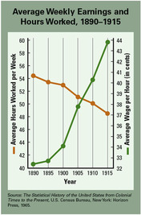
The Pullman Strike revealed one way the federal government could intervene to favor employers over unions. To end the strike, a federal court issued an injunction against the American Railway Union and its head, Eugene V. Debs. An injunction is a court order that prohibits a specific action. The court based the injunction on a broad interpretation of the Sherman Antitrust Act. This act was designed to prohibit trusts and monopolies. Now it was being used against striking workers, on the grounds that their strike limited trade and commerce.
When Debs and other railway union leaders ignored the injunction, they were arrested and sent to jail. Later the Supreme Court ruled, in the case In re Debs, that such a broad, or "blanket," injunction was legal. After that decision, federal judges could and did shut down any strikes or boycotts that they ruled to be "conspiracies in restraint of trade."
To thrive, unions needed the support and respect of the American people. They failed to win either. The violent nature of strikes and of events like the Haymarket Affair caused many Americans to view union members as dangerous radicals. Violence and radicalism also weakened unions by scaring away potential union members.
Gains: Unions Win Small Bread-and-Butter Victories Most unions remained relatively small in the late 1800s. Only about 10 percent of the employed labor force joined unions. Yet for that minority, work hours and wages improved steadily. From 1890 to 1915, average work hours per week for union employees fell from 54 to 49. At the same time, weekly pay rose from $17.60 to $21.30.
Wages and hours for nonunion workers also improved, though not to the same degree. Skilled laborers, whether union or nonunion, made the greatest gains. Most unskilled laborers, consisting largely of white women, African Americans, and new immigrants, still struggled to make ends meet.
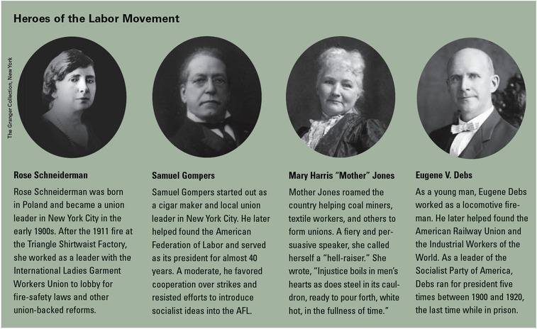
Unions achieved more than just better wages, hours, and working conditions. They also won some recognition of workers' rights. They challenged an economic system in which owners could treat their workers no better than machines. Unions insisted that workers should be able to sit down with owners, as equals, at the bargaining table. This in itself gave some power to the working class, where it had little or none before.
Section 6:
The efforts of industrial workers in the late 1800s helped boost the American economy. Yet factory owners often treated their workers poorly, imposing low wages, long hours, and poor working conditions. Many workers joined labor unions to fight for better treatment and to raise their standard of living. But hostility between unions and employers sometimes led to violence.
Working-class conditions The working class suffered greatly during the Gilded Age. Industrial workers accepted low pay and dangerous conditions because they could not afford to lose their jobs. Many working-class families occupied run-down tenements in poor city slums.
Child labor American industry relied on the labor of whole families, including children, who often worked longer hours than adults.
Labor unions Workers united to form labor unions and to negotiate better wages and working conditions. Union membership increased with the rise of national unions and labor federations, such as the American Federation of Labor.
Strikes Failed negotiations led often to strikes and sometimes to violence. The government generally took the side of business and industry and often helped to break strikes.
Losses and gains for workers Periodic depressions shrank union membership, while violent incidents like the Haymarket Affair, Homestead Strike, and Pullman Strike helped turn public opinion against unions. However, unions gained wage increases and reductions in work hours.

